Description / Scope |  | Product Listings |  | Production Process
${csProcessRisk_description} |  | ${csProcessRisk_listings} |  | ${csProcessRisk_process}

Storage Conditions |  | Shelf Life |  | CCPs Identified in Group
${csProcessRisk_storageConditions} |  | ${csProcessRisk_shelfLife} |  | ${csProcessRisk_ccpsPresent}

HACCP Team
Name | Department | Qualification | Role
${csProcessRiskTeam_name} | ${csProcessRiskTeam_department} | ${csProcessRiskTeam_qualification} | ${csProcessRiskTeam_role}

HACPP Group Flow
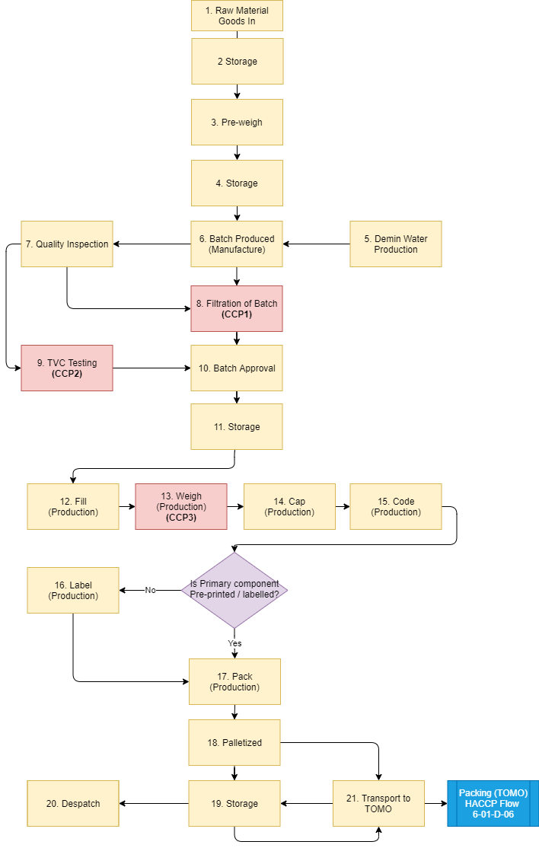

CCP Decision Tree
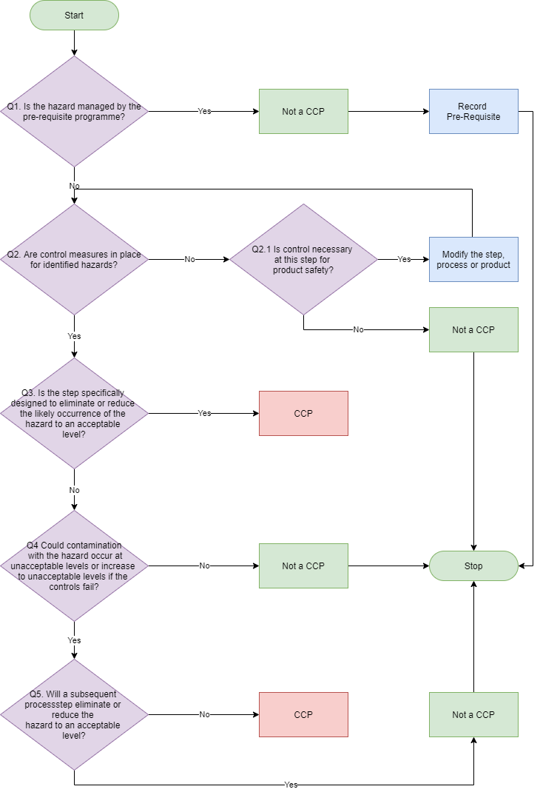

  Likelihood Levels will be determined using the following definitions
  Risk Level | Definition
  ${csProcessRiskRating_lLevel} | ${csProcessRiskRating_lDescription}
  Risk Level x Severity Level = Hazard Score
   | 1 | 2 | 3
  1 | 1 | 2 | 3
  2 | 2 | 4 | 6
  3 | 3 | 6 | 9
  Severity Levels will be determined using the following definitions
  Risk Level | Definition
  ${csProcessRiskRating_sLevel} | ${csProcessRiskRating_sDescription}
  Hazard Score RPN Level
  1 - 2 | Low
  3 - 4 | Medium
  6 | High
  9 | Very High

Hazard Analysis
Process Step |  | Hazzard | Potential Hazard | Risk Likelihood  [1 -3] | Risk Severity  [1 -3] | Risk Score  [L x S] | Pre-Requisites | Control measures | Q1 | Q2 | Q3 | Q4 | Q5 | CCP? | CCP ID
1 | Raw Material Goods In | S L | Incorrect material | 1 | 3 | 3 | 3. Control of Non-Conforming Materials, 12. Product Specifications, 13. Raw Materials and Packaging | 3-04-1 - Goods In - Receiving, All raw materials approved and agreed against specifications, 7-01-1 - Training and Competency | Y | NA | NA | NA | NA | Not A CCP | NA
1 | Raw Material Goods In | C A S L | Incorrect grade of material | 1 | 3 | 3 | 3. Control of Non-Conforming Materials, 12. Product Specifications, 13. Raw Materials and Packaging | 3-04-1 - Goods In - Receiving, All raw materials approved and agreed against specifications, 7-01-1 - Training and Competency | Y | NA | NA | NA | NA | Not A CCP | NA
1 | Raw Material Goods In | S L P | Incorrect bottle, cap or label | 1 | 3 | 3 | 3. Control of Non-Conforming Materials, 12. Product Specifications, 13. Raw Materials and Packaging | 3-04-1 - Goods In - Receiving, All raw materials approved and agreed against specifications, 7-01-1 - Training and Competency | Y | NA | NA | NA | NA | Not A CCP | NA
1 | Raw Material Goods In | C M P | Unhygienic delivery vehicles | 1 | 3 | 3 | 3. Control of Non-Conforming Materials, 12. Product Specifications, 13. Raw Materials and Packaging | 3-04-1 - Goods In - Receiving, Vehicle inspection, 7-01-1 - Training and Competency | Y | NA | NA | NA | NA | Not A CCP | NA
1 | Raw Material Goods In | P M | Contamination of outer packaging by rodents and bird dropping and damaged/split bags | 1 | 3 | 3 | 3. Control of Non-Conforming Materials, 12. Product Specifications, 13. Raw Materials and Packaging | 3-04-1 - Goods In - Receiving, Raw materials stored outside are wrapped. Pest Control system. Outer packaging materials stored in doors. , 7-01-1 - Training and Competency | Y | NA | NA | NA | NA | Not A CCP | NA
1 | Raw Material Goods In | C M P A | Contaminated / Damaged Pallets | 2 | 3 | 6 | 3. Control of Non-Conforming Materials, 12. Product Specifications, 13. Raw Materials and Packaging | 3-04-1 - Goods In - Receiving, 7-01-1 - Training and Competency | Y | NA | NA | NA | NA | Not A CCP | NA

Critical Control Points
Process Step Number |  | CCP ID | Control Measures/Pre-Requisites | Critical Limits(s) | Monitoring | Corrective Action(s) | Record(s) Used
8 | Filtration of Batch | CCP-001 | Filter | Free from tears and rips in the filter | Frequency | Ensure filter size used as per bulk specification  If filter burst/rips, stop pump & quarantine stock.  Alert Production Manager/Quality Manager | QC034 Batch Sheet.
 |  |  |  |  | Every batch produced and filled |  | QC034 Batch Sheet.
 |  |  |  |  | Responsibility |  | QC034 Batch Sheet.
 |  |  |  |  | Manufacturing - Team Leader |  | QC034 Batch Sheet.
 |  |  |  |  | How |  | QC034 Batch Sheet.
 |  |  |  |  | SOP100 - Control of Filtration |  | QC034 Batch Sheet.
8 | Filtration of Batch | CCP-001 | Filter | Free from tears and rips in the filter | Frequency | Ensure filter size used as per bulk specification  If filter burst/rips, stop pump & quarantine stock.  Alert Production Manager/Quality Manager | QC034 Batch Sheet.
 |  |  |  |  | Every batch produced and filled |  | QC034 Batch Sheet.
 |  |  |  |  | Responsibility |  | QC034 Batch Sheet.
 |  |  |  |  | Manufacturing - Team Leader |  | QC034 Batch Sheet.
 |  |  |  |  | How |  | QC034 Batch Sheet.
 |  |  |  |  | SOP100 - Control of Filtration |  | QC034 Batch Sheet.
8 | Filtration of Batch | CCP-001 | Filter | Free from tears and rips in the filter | Frequency | Ensure filter size used as per bulk specification  If filter burst/rips, stop pump & quarantine stock.  Alert Production Manager/Quality Manager | QC034 Batch Sheet.
 |  |  |  |  | Every batch produced and filled |  | QC034 Batch Sheet.
 |  |  |  |  | Responsibility |  | QC034 Batch Sheet.
 |  |  |  |  | Manufacturing - Team Leader |  | QC034 Batch Sheet.
 |  |  |  |  | How |  | QC034 Batch Sheet.
 |  |  |  |  | SOP100 - Control of Filtration |  | QC034 Batch Sheet.

Review
Review Version/Date | Review Reason | Review Findings
Version ${csProcessRiskReview_version} | Reviewed ${ csProcessRiskReview_reviewDate} | ${csProcessRiskReview_reviewReason} | ${csProcessRiskReview_reviewFindings}.

